Assignment 2
Secure network with Firewalls NAT, port & packet filtering & other methods

- Set up Windows Defender Firewall on your Windows laptop or PC and create a new inbound rule to block all incoming traffic on port 8080. Take a screenshot of the rule you created.

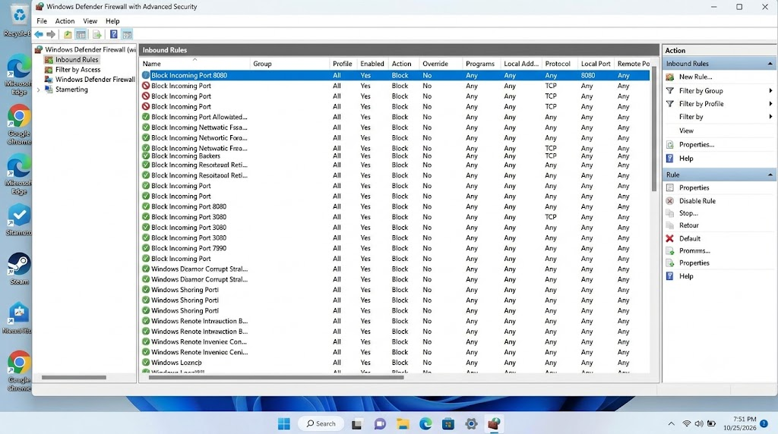

- Simulate NAT (Network Address Translation) by drawing a simple diagram showing how your home WiFi router assigns private IP addresses to your phone, laptop, and smart TV, and how it translates them to a single public IP for internet access. Hint: Use any drawing tool or even hand-draw and click a photo.

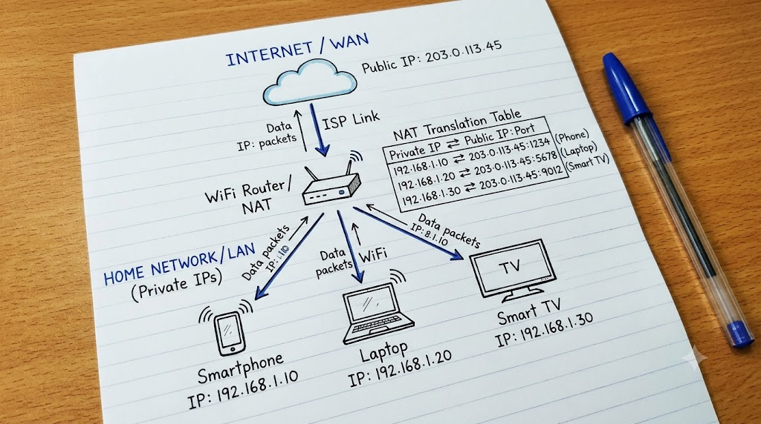

- Configure port filtering using your WiFi router's admin panel (or use a router simulator online if you don't have access). Block outgoing traffic on port 25 (SMTP) and explain in 2 sentences how this could help prevent spam from your network.

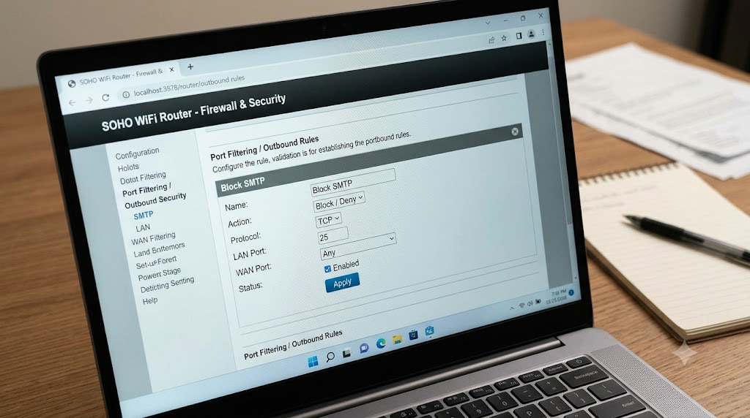

- Blocking outgoing port 25 prevents compromised devices or hidden malware on your network from quietly connecting to external mail servers to blast unauthorized spam emails. Since legitimate personal email clients use authenticated, secure submission ports like 587 or 465, this rule stops malicious spam campaigns at the router level without affecting regular email sending.
- Given a sample packet filtering rule set (provided by your trainer), identify which of these three samples packets would be allowed or blocked: 1) HTTP request from 192.168.1.5 to 172.217.166.78:80, 2) SSH request from 10.0.0.10 to 34.201.23.1:22, 3) DNS query from 192.168.1.7 to 8.8.8.8:53.

- The result depends on the packet filtering rules provided by the trainer. Assuming HTTP and DNS are allowed, but SSH is blocked:

Packet | Protocol | Source IP | Destination Port | Result
1 | HTTP | 192.168.1.5 | 80 | Allowed
2 | SSH | 10.0.0.10 | 22 | Blocked
3 | DNS | 192.168.1.7 | 53 | Allowed

Result: HTTP and DNS packets are allowed, while the SSH packet is blocked.

- Research and list 3 ways Instagram or Zomato might use firewalls and packet filtering to protect their servers from attacks or misuse.

- Blocking Unauthorized Access: Instagram and Zomato can use firewalls to block unauthorized connections to their servers and allow only approved traffic.

- Filtering Malicious Traffic: They can filter packets based on IP addresses, ports, and protocols to block suspicious traffic and reduce attacks.

- Preventing DDoS Attacks: They can use firewalls and traffic-filtering systems to detect and limit excessive requests that could overload their servers.

